**PHARMACY DATABASE RESULTS AND VISUALIZATIONS**

We created this DB with Mockaroo. It’s a pharmacy’s daily business activities. Through it, the business can gain insights that will guide its strategic decision-making.

It has the following tables:

1. Prescriptions
2. Doctors
3. Patients
4. Medications

**Business Problems.**

1. ***Calculate the average transaction amount for each payment method used***

Insights from this will inform on:

* Resource allocation toward enhancing payment compatibility to maximize customer satisfaction and efficiency.
* Fraud activities as unexpected revenues will be suspicious.
* Promotional strategies e.g., incentives for using insurance
* Profitability per payment method

1. ***Calculate the total number of prescriptions issued each month for the past year, grouped by month***

Insights from this will inform on:

* Patient education for conditions prevalent in certain months e.g., flu in July
* Marketing resources allocation in the peak months e.g., November to maximize revenues
* Inventory adjustment to match expected monthly sales e.g., sufficient inventory to see through November.
* Plotting monthly sales growth and setting targets

1. ***Retrieve the patients who have prescriptions for medications that are out of stock.***

Insights from this will inform on:

* Communication with the relevant customers and providing alternatives to enhance efficiency and customer satisfaction
* Prioritizing Inventory replenishment

1. ***Calculate the total revenues generated from each medication, considering the quantity sold and the price per unit.***

Insights from this will inform on:

* Prioritizing resources and investments to drugs that reflect high demand
* Cost analysis to assess profitability for each drug
* Price negotiations with suppliers to manage the cost of doing business.
* Price adjustments to boost sales for struggling SKUs or capitalize on profits due to good sales.

1. ***Find the most commonly prescribed medication and the corresponding doctor who prescribed it.***

Insights from this will inform on:

* Aligning the prescriptions with respective ailments and carrying patient health education.
* Training of doctors to enrich their knowledge as they are the best medium of communication with patients.
* Demand assessment and inventory replenishment

***VISUALIZATIONS***

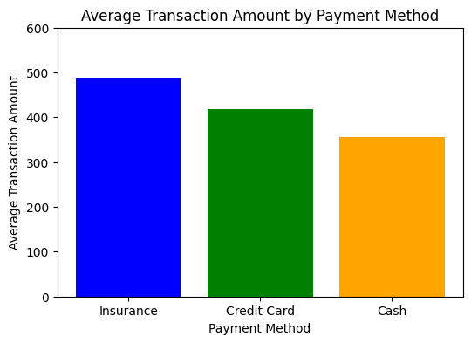

2.

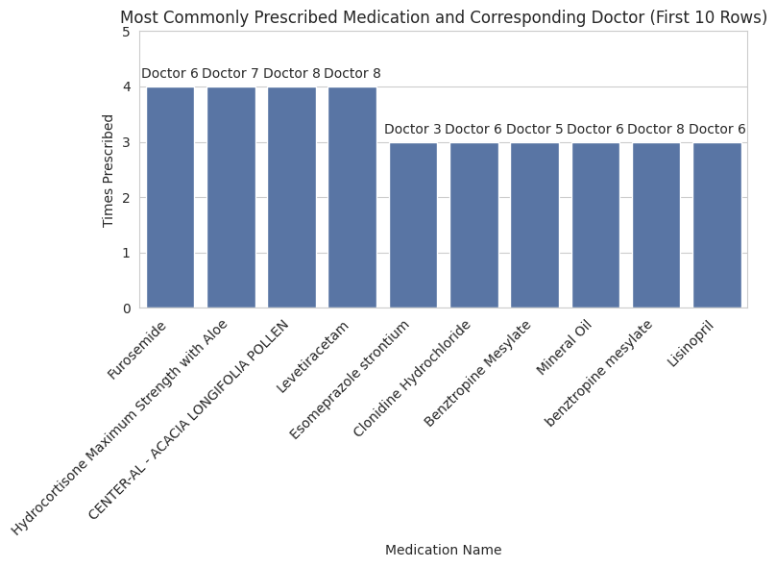

3.

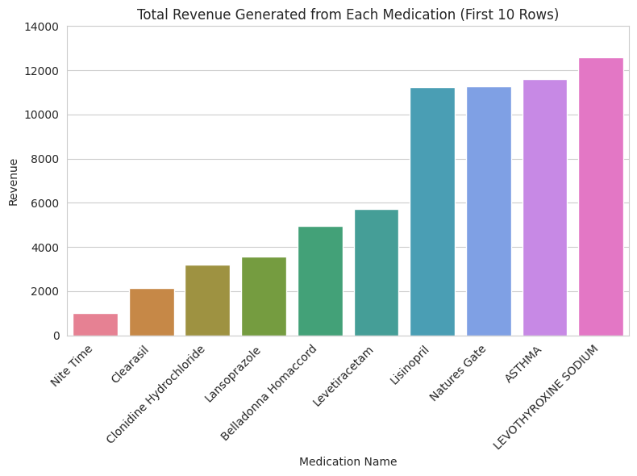

4.

